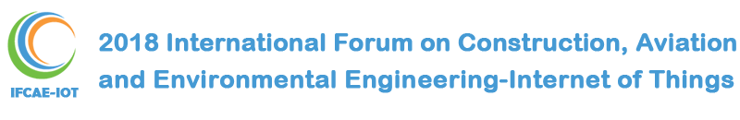

Guangzhou,China
May 11-13 2018

http://www.gdaiae.org/ifcae-iot2018

2018 International Forum on Construction, Aviation and Environmental Engineering- Internet of Things
（IFCAE-IOT 2018）

Latest News

- IFCAE-IOT2018 official website is available and submission is opened now! [2017-12-14]
- IFCAE-IOT2018 is included in MATEC Web of Conferences. [2017-12-14]

Conference Overview
The 2018 International Forum on Construction, Aviation and Environmental Engineering-Internet of Things(IFCAE-IOT 2018) will be held in Guangzhou City Construction College, Guangzhou, China during May 11-13, 2018. The organizer of the conference is Vanung University(Taiwan), Taiwan Society of Construction Engineering, Guangzhou City Construction College, China and Guangdong Academy of International Academic Exchange.
The theme of IFCAE-IOT 2018 is "Development of Construction Automation".

In addition to the high technical standard expected of this conference, we aim to give all participants a real taste of the true Chinese culture in the beautiful Guangzhou. The dedicated conference teams are currently working hard on making this conference not only intellectually stimulating but also an unforgettable pleasant experience.
We warmly invite you to participate in IFCAE-IOT 2018 and look forward to seeing you in Guangzhou!

Publication
1. Publish in MATEC Web of Conferences(ISSN(Electronic Edition): 2261-236X)
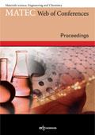 | All submissions will be peer reviewed by 2-3 reviewers. All the registered and presented papers will be published in MATEC Web of Conferences(ISSN(Electronic Edition): 2261-236X), which are to be indexed by Elsevier: SCOPUS www.scopus.com, Index Copernicus Journals Master List www.indexcopernicus.com, Google Scholar scholar.google.com, Ei Compendex (CPX) www.ei.org/, Cambridge Scientific Abstracts (CSA) www.csa.com, Inspec (IET, Institution of Engineering Technology) www.theiet.org, SCImago Journal & Country Rank (SJR) www.scimagojr.com, EBSCO www.ebsco.com. All the volumes of the proceeding will be submitted to Thomson Reuters (WoS) and selected ones will be indexed.  Conference list of MATEC Web of Conferences journal
2. Publish in special issue of International Journal for Simulation and Multidisciplinary Design Optimization(IJSMDO)(ISSN : 1779-6288)
( It will accept 15 papers.)

Keynote Speakers
- 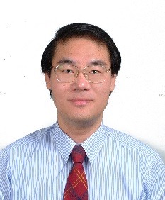

Prof.Wen-Pei Sung
Lifetime Distinguished Professor and Dean at the college of Humanities and Creativities, National Chin-Yi University of Technology
- 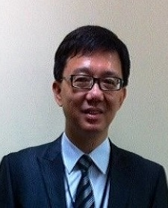

Prof.Chih-Ming Kao
Chair Professor, Institute of Environmental Engineering, National Sun Yat-Sen University, Taiwan

Prof.Thomas C. Chuang
President of Vanung University, Taiwan, which is known for her excellent tourism and culinary art programs.
- 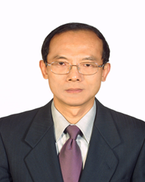

Ph.D. Tao-Yun Han
President of Taiwan Society of Construction Engineering, Ph.D, Dept. of Civil Engineering and Engineering Information, Chung Hua University，Taiwan
- 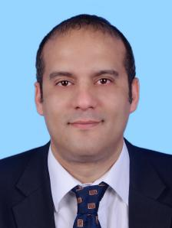

Prof.David BASSIR
French University of Technology UTBM and Senior Researcher at the Mathematical Center & Applications (CMLA), CNRS -UMR 8536 – ENS Cachan (France)

Prof.Wen-der Yu
Department of Construction Engineering, Chaoyang University of Technology, Taiwan

Submission
Important Dates
Submission Deadline：Mar.15, 2018
--------------------------------------------------------
Notification Date：Apr.15, 2018
--------------------------------------------------------
Registration Deadline：May.1, 2018
--------------------------------------------------------
Conference Date：May.11-13, 20118
Contact Us
Contact Person：Dr.Zhong
--------------------------------------
IFCAE@gdaiae.org
--------------------------------------
+86-18102552506
--------------------------------------
+86-020-28344314
--------------------------------------
1906236854
--------------------------------------
18102552506

Sponsor
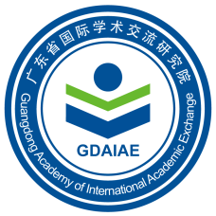
Guangdong Academy of International Academic Exchange

Vanung University

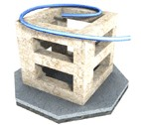
Taiwan Society of Construction Engineers

Guangzhou City Construction College

Official Wechat
Follow us

http://www.gdaiae.org/IFCAE-IOT2018

2018 International Forum on Construction, Aviation and Environmental Engineering -Internet of Things
（IFCAE - IoT 2018）

2018年建筑、航空与环境工程国际学术论坛 - 物联网

大会时间：2018年 5月 11-13日
大会地点：中国▪广州大学城

Cooperation Agreement

最新消息
- IFCAE-IOT2018官方網站可用，現在提交打開！ [ 二〇一七年十二月十四日 ]
- IFCAE-IOT2018包含在MATEC會議網頁中。 [二〇一七年十二月十四日]
會議概述

在 對建築，航空與環境工程，物聯網（2018國際論壇IFCAE-IOT 2018） 將舉行廣州城市建設學院，廣州，中國2018 5月11-13日，在此期間。會議的組織者是台灣的Vanung大學，台灣建築工程學會，廣州市建築學院，中國和廣東省國際學術交流研究院。

IFCAE-IoT 2018的主題是 “ 建築自動化的發展 ”。

除了本次會議期待的高標準技術標準之外，我們的目標是讓所有參與者真正品味到美麗的廣州真正的中國文化。專門的會議團隊正在努力使這次會議不僅在智力上激發，而且是一個令人難忘的愉快的經歷。

我們熱烈邀請您參加IFCAE-IOT 2018， 並期待在廣州見到您！

出版物

1. 在 MATEC Web會議上發布（ISSN（電子版）：2261-236X）
所有提交的內容將由2-3位評審者進行同行評審。所有註冊和發表的論文將在 MATEC會議網站（ISSN（電子版）：2261-236X）上發布，這些會議將由Elsevier索引： SCOPUS www.scopus.com，索引哥白尼期刊碩士列表www.indexcopernicus。 COM，谷歌學術scholar.google.com， 工程索引（CPX）www.ei.org /，劍橋科學文摘（CSA）www.csa.com，INSPEC（IET工程技術學會）www.theiet.org，SCImago雜誌和國家排名（SJR）www.scimagojr.com，EBSCO www.ebsco.com 。所有的程序將提交給 湯森路透（沃森） 和選定的將被索引。
MATEC Web會議期刊會議名單

2. 發表在 國際期刊上的模擬與多學科設計優化（IJSMDO）（ISSN：1779-6288） （將接受15份文件。）

主講嘉賓
溫培培教授
中國科技大學人文與創新學院終身特聘教授，院長

高智明教授
國立中山大學環境工程學院講座教授

托馬斯·C·莊教授
以優秀的旅遊和烹飪藝術項目聞名的台灣Vanung大學校長。

博士 韓濤雲
台灣中華大學建築工程學會會長，土木工程及工程信息系博士

大衛·巴塞爾教授
法國科技大學UTBM和數學中心及應用（CMLA）高級研究員，CNRS -UMR 8536 - ENS Cachan（法國）

俞教授
朝陽科技大學建築工程系台灣

服從

重要的日子
提交截止日期：2018年3月15日
------------------------------------------ -------- ------
通知日期： 2018年4月15日
------------------------------------------ -------- ------
註冊截止日期：2018年5月1日
------------------------------------------ -------- ------
大會日期： 2011年5 月11 - 13日
聯繫我們
聯繫人：鐘博士
--------------------------------------
IFCAE@gdaiae.org
--------------------------------------
+ 86- 18102552506
--------------------------------------
+ 86- 020-28344314
--------------------------------------
1906236854
--------------------------------------
18102552506

贊助
廣東省國際學術交流研究院
-------------------------------------------------- ---
Vanung大學
-------------------------------------------------- ---
台灣營建工程師學會
-------------------------------------------------- ---
廣州市建築學院
-------------------------------------------------- ---

官方微信
跟著我們
合作協議

